Maze to nodes Nodes to graph Graph to Weighted Shortest path  
 graph algorithm

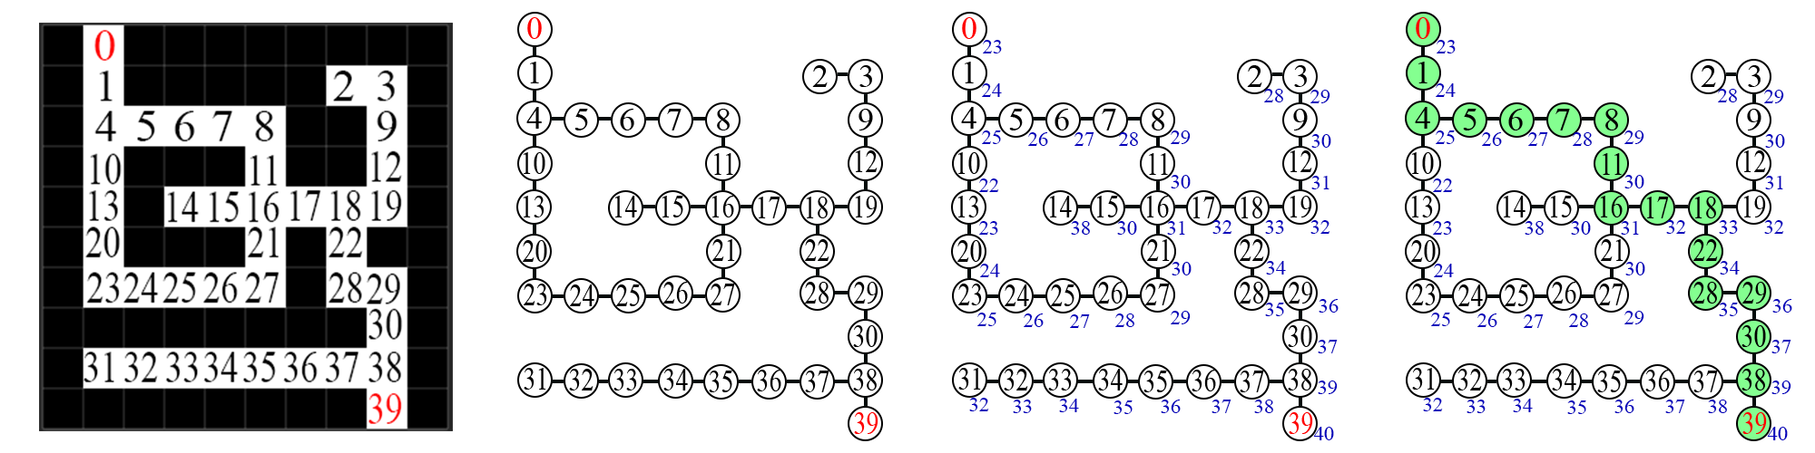

|  |  |  |
| --- | --- | --- |
| Algorithm\Complexity | Time | Space |
| Graph Building | O(n*m) + O(k) + O(k^2) = O(n*m)  *n-width of picture*  *m-height of picture*  *k-white pixels(nodes)*  k^2 < n*m | O(V+E)  *V-nodes in graph E-edges* |
| Graph to Weighted Graph | O(V*E) | O(V+E) |
| Path Finding | O(p*e)  *p-path length*  *e-edges along the path* | O(V+E) |
| Total | **O(n*m)** | **O(V+E)** |